**Name : Umer yousuf**

**Class : bcs-6H**

**Q1:**

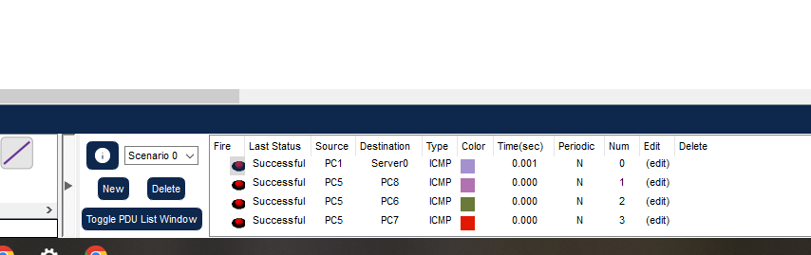

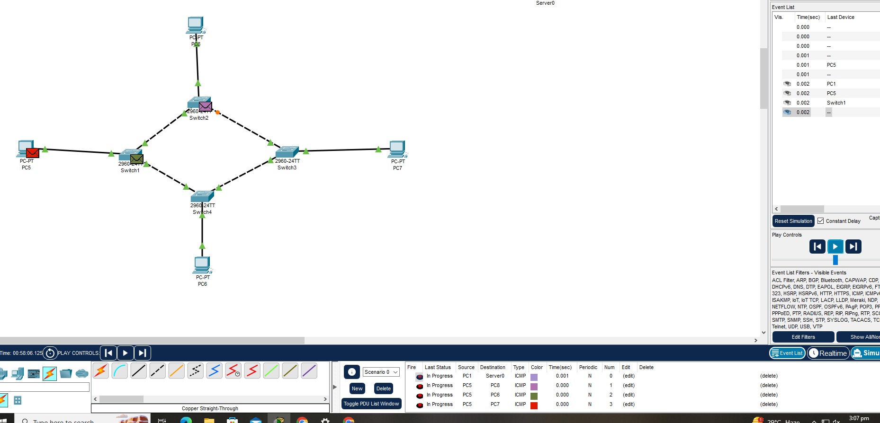

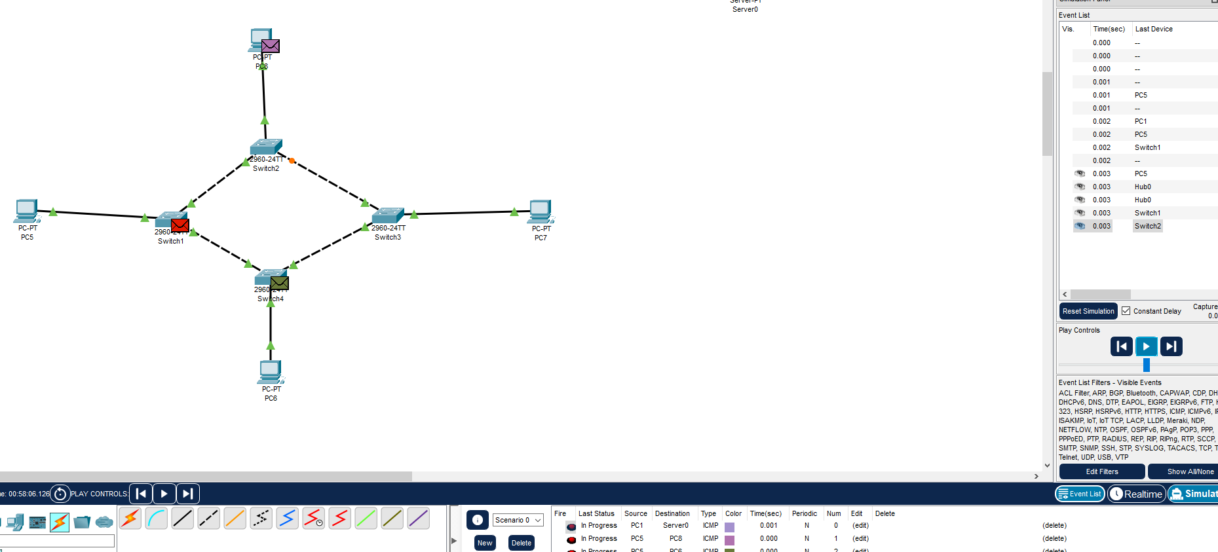

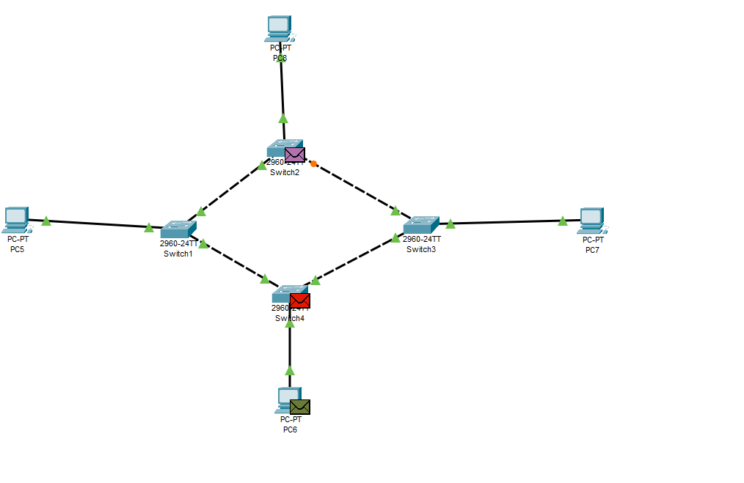

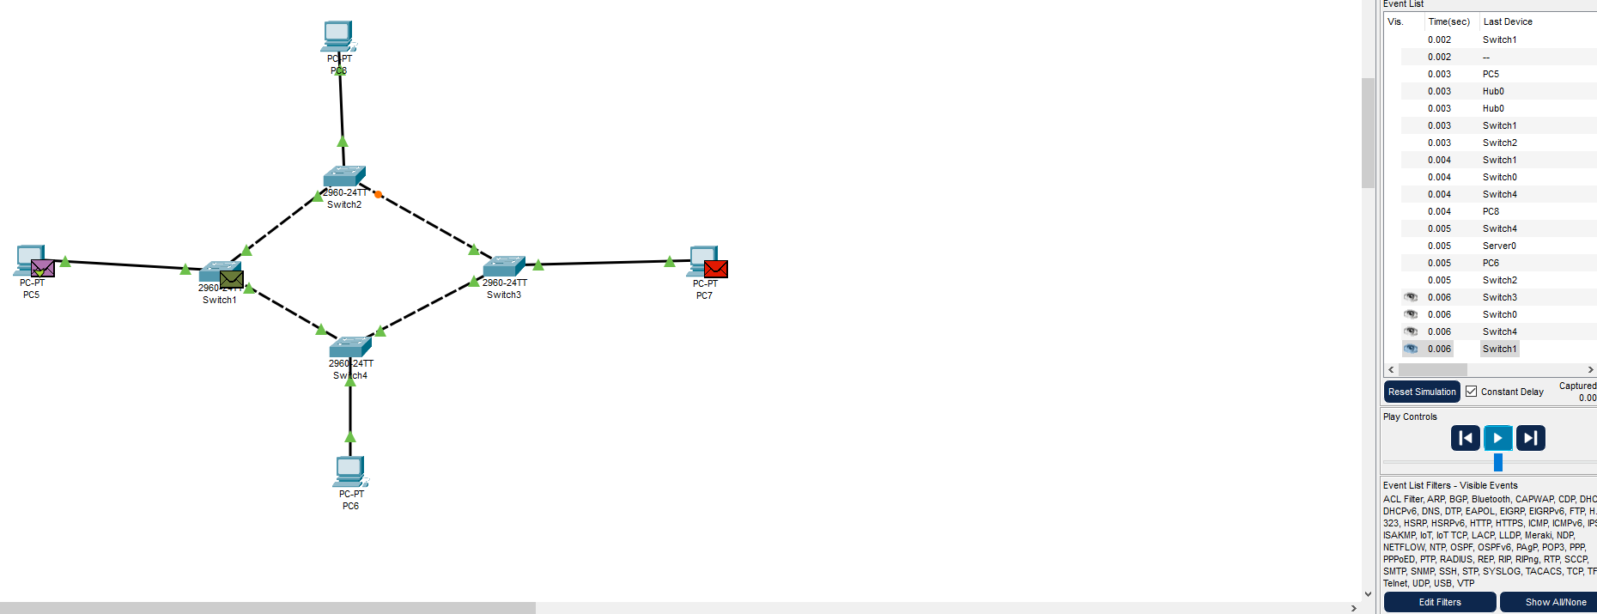

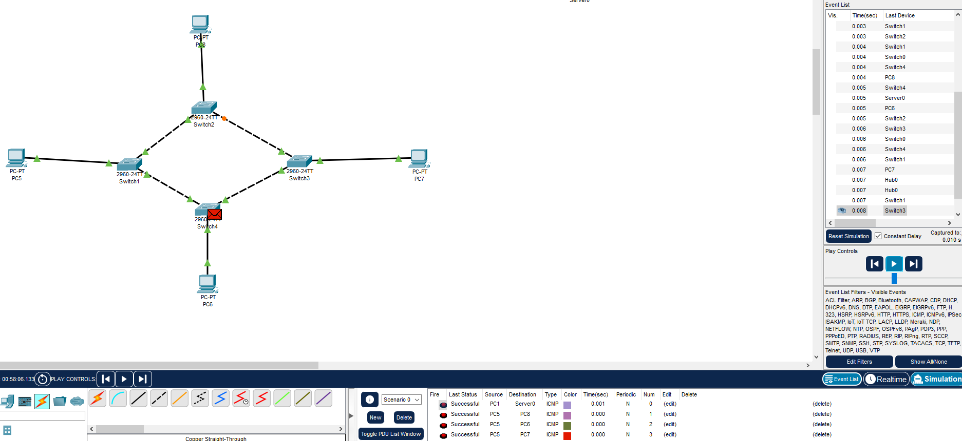

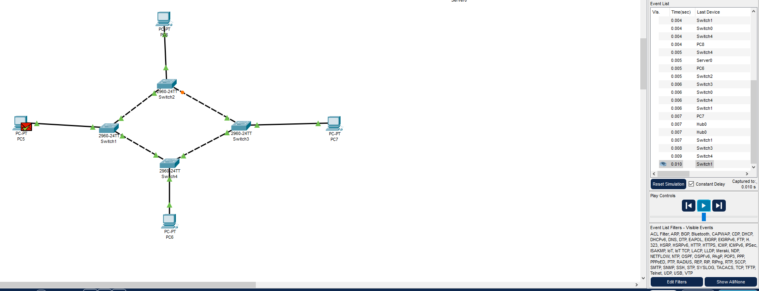

**2) Identify the difference between Switch and Hub?**

Hubs:

Broadcast data to all devices. Shared bandwidth, slower performance.

Switches:

Forward data only to intended recipients. Dedicated bandwidth, faster performance.

**3) Differentiate between physical and logical modes?**

**Physical:**

Deals with the actual storage and access of data on a device.

example:A file stored on your hard drive.

**Logical:**

Focuses on the structure and relationships within the data itself.

example:The table structure in a database.

**Q5:**

